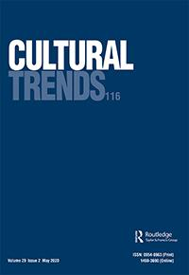**Cultural Trends**

**ISSN: (Print) (Online) Journal homepage:** [**https://www.tandfonline.com/loi/ccut20**](https://www.tandfonline.com/loi/ccut20)



**Do state funding, geographic location, and networks matter?**

**The case of prominent Irish actors, directors and writers**

**John O'Hagan , Denis Murphy & Ruth Barton**

**To cite this article:** John O'Hagan , Denis Murphy & Ruth Barton (2020) Do statefunding, geographic location, and networks matter?, Cultural Trends, 29:2, 77-95, DOI: [10.1080/09548963.2020.1768026](https://www.tandfonline.com/action/showCitFormats?doi=10.1080/09548963.2020.1768026)

**To link to this article:** <https://doi.org/10.1080/09548963.2020.1768026>



Published online: 22 May 2020.



[Submit your article to this journal](https://www.tandfonline.com/action/authorSubmission?journalCode=ccut20&show=instructions) 



Article views: 84



[View related articles](https://www.tandfonline.com/doi/mlt/10.1080/09548963.2020.1768026) 



[View Crossmark data](http://crossmark.crossref.org/dialog/?doi=10.1080/09548963.2020.1768026&domain=pdf&date_stamp=2020-05-22)



Full Terms & Conditions of access and use can be found at

<https://www.tandfonline.com/action/journalInformation?journalCode=ccut20>

CULTURAL TRENDS



2020, VOL. 29, NO. 2, 77–95

https://doi.org/10.1080/09548963.2020.1768026



Do state funding, geographic location, and networks matter? The case of prominent Irish actors, directors and writers1

John O’Hagan, Denis Murphy and Ruth Barton

aDepartment of Economics, Trinity College, Dublin, Ireland; bDepartment of Film, Trinity College, Dublin, Ireland



ABSTRACT

Using a uniquely constructed data set, we look at the ecologies of creative careers in film/TV-drama/theatre, using a detailed interview questionnaire case study of eighty-two prominent workers in the Irish film/TV-drama/theatre sectors. Three influences on career progression are given special attention: state patronage, geographic location and networks. There is strong evidence to show that those interviewed consider state patronage as very important to their career development, particularly in relation to “breakthrough” events. Even this group depends on outside work, particularly in advertising, to supplement incomes. Our findings confirm that prominent creative workers tend to be geographically concentrated and consider such proximity to other creative workers as important. A very large proportion of them also consider networks/personal connections as very important to career success, in terms of three main advantages: work/job contacts, the generation of new ideas and moral support/ understanding.

KEYWORDS

Creative careers; theatre; film/TV; state funding; networks; geographic location

Introduction

The focus of this paper will be on career construction in film, TV-drama and theatre – how do the more prominent creative people enter the fields of filmmaking and theatre, and how do they build and develop their careers? There have been very few if any studies like this using survey data, although the careers of other creative workers, using large on-line encyclopaedias, have been examined in a historical context (see Borowiecki, 2013; Hellmanzik, 2010; Mitchell, 2019; and O’Hagan & Walsh, 2016).

The data source is a comprehensive interview survey of 82 prominent creative workers (actors, writers, and directors in film, TV-drama and theatre). “Prominence” is defined for the purposes of this paper as relating to those who won Irish awards or were nominated for major awards overseas (the nomination being considered a marker of prominence due to the more competitive nature of the major international awards). As such, the concen-tration is on established creative workers, thereby complementing the emphasis in other papers on early-career creative workers and hence providing a more holistic over-view (see for example, Comunian et al., 2011; and Noonan, 2015). To inform our knowledge



CONTACT John O’Hagan  [johagan@tcd.ie](mailto:johagan@tcd.ie)

© 2020 Informa UK Limited, trading as Taylor & Francis Group

78  J. O’HAGAN ET AL.

of the ecology of creativity in the film/TV-drama and theatre sectors, and using the infor-mation elicited from these data, the paper aims to do the following.2

.

.

.

.

.

Understand more fully how creative workers in film, TV-drama and theatre enter the sector and progress their careers

Examine the role of state funding in their education and later career development Examine their geographical distribution in terms of potential locational clustering Examine the extent to which creative workers in these sectors supplement their incomes from other sources

Examine the evolution and impact of early creative connections (e.g. family, drama societies, etc.)

Careers are shaped by expanding spheres of influence by what Bronfenbrenner (1979) calls “the ecology of human development.” Family, school, community, region, and nation might provide diﬀerential opportunities, models, rewards, resources, and recognition. As such, the use of the term “ecology of creative careers” seems an apt term to apply in this study.

Section “Relevant features of the market for creative workers” will set out the relevant labour market issues upon which we wish to throw light and hence shape the design of the questionnaire. Issues such as sources of income, the operation of the labour market in which creative workers find themselves and the importance of geographical and network eﬀects are all highlighted. Section “Choice of sample of creative workers and questionnaire” will outline details regarding the survey and questionnaire used. Section “Findings: education and state patronage” will present the key findings in terms of edu-cation and background of the sample, while Section “Findings: geographic location, sup-plementary work and networks” will examine the core issues of the paper: namely the role of state funding in career progression, the extent of supplementary work undertaken, geo-graphical location and networks eﬀects with other creative workers. Section “Concluding reflections” provides some concluding observations.

The unique data set constructed provides important new evidence on each of these issues, by asking directly the creative workers under study their views as opposed to trying to infer from them through written material (see Hellmanzik, 2010; and Mitchell, 2019). The role of state funding in career progression has been discussed widely (see O’Hagan, 2016 and references therein), but rarely has evidence such as this been provided. The survey also provides new evidence on the nature of supplementary work undertaken, not only in terms of its nature but also to what extent it is considered creative. The same applies to the evidence provided on the extent and perceived importance of geographical location and networks, factors considered very important to career progression in many studies (see Borowiecki, 2013; Hellmanzik, 2010; Mitchell, 2019 and O’Hagan & Walsh, 2016). This study allows us to dig deeper, to ascertain what are perceived as the advan-tages of such networks.

Relevant features of the market for creative workers

This section will review aspects of the market for creative workers which influenced the choice and focus of the questions in the survey. The objective was to throw light on

CULTURAL TRENDS  79

the extent to which these features apply in Ireland, at a level of detail made possible by the survey design. The first of these is the source of incomes for the type of creative workers being studied, with special emphasis on the role played by income and other supports provided by the state. And, also the extent to which they must rely on other sources of income. The fact that many creative workers are in eﬀect freelance entrepreneurs, often dependent on agents, impacted also the design of the survey and these aspects of the labour market in which they operate are also examined. Finally, the eﬀect of location and the resultant networks on the success of creative workers has been the focus of many studies and hence was of considerable interest to the design of this study. Each of these factors will now be discussed.

Sources of income

One of the earliest and perhaps most interesting overviews of the market for creative workers can be found in Frey and Pommerehne (1989). Their focus was on the incomes of creative people, where they argue that in every other profession the best worker is paid the most, but not necessarily so in the creative sector. In fact, in cinema and TV pro-duction it could be argued that the opposite often holds: the creation of less innovative but more marketable works may often be the most financially rewarding.3

A feature of the incomes of creative people is that they are usually derived from various sources (see for example, Throsby & Zednik, 2011). Creative workers in the sectors on which this paper is focused are mostly self-employed, with very variable employment conditions and hence unpredictable income.4 Many have other jobs at least tangentially related to their art: teaching, working on commercials, doing voice-overs, acting in radio plays, etc. Some less financially secure people may even have to undertake work totally unrelated to their art, such as restaurant or retail jobs. The survey inquired into this aspect of their income situation but did not ask for data on incomes per se.5 Specifically, we asked to what extend the interviewees relied on sup-plementary income, from say advertising, voice-overs and so on. A heavy reliance on these would suggest an income deficiency but we also enquired to what extent the sup-plementary work is considered creative, hypothesizing that creative workers would judge such work to be more satisfying.

State patronage

There is also income available through patronage. In the past, the Church was the major patron, and later the bourgeois merchant class who had acquired surplus wealth. Today, at least in Europe, patronage is derived mostly from the state at various levels, for example through direct grants for cultural production, indirectly benefitting creative workers by increasing employment opportunities. State (or public) patronage is usually given where the market on its own would not support the activity. Examples are innovative theatre work; experimental design; work aimed at minority audiences; arts that challenge or cri-tique societal norms; and so on (see O’Hagan, 2016).

Much of this work is not obviously commercial and requires market support, not just for the writer who creates the original script, but also for the designers, technicians and actors who further develop and perform the new work. Patronage can thus encourage artistic innovation that, left purely to market forces, might otherwise not happen. It is interesting

80  J. O’HAGAN ET AL.

to see the extent to which the interviewees for this study indicate that state patronage impacted on their careers.

Related to state patronage are exchequer-led measures like tax breaks, tax credits and tax refunds, which also contribute to the cultural production “ecology”. Film production (both the commercial and “arthouse” variety) is now routinely carried out on a global or transnational basis, incentivized by generous tax credits and other state subsidies. The scale of such incentives is driven by the desire of many countries to attract mobile film investment, providing valuable employment opportunities but also potential spin-oﬀ benefits such as film tourism. In this sense, they are part of industrial policy rather than cultural policy per se.6 There are also in Ireland and elsewhere VAT concessions applying to attendance at theatres and, also, there is an exemption from income tax for some crea-tive workers.

Some of these tax breaks apply directly to the group under study here, in particular to writers, so questions relating to this were included in the questionnaire.

Education system and awards/prizes

In many countries, the education system is funded at least partly by the state. The latter is certainly the case in Ireland, where even private primary and secondary schools receive significant state subvention. While “free” education in Ireland is often accompanied by substantial “registration fees” that must be borne by students and parents, the major costs are nevertheless met from the public finances. Thus – as with most other occupations

– the state is a major funder of career initiation and development through its support of film and drama studies at degree and postgraduate level, an aspect of state patronage that must not be overlooked. Our study also probes the relevance of alternative professional training organizations – both public and private – to career construction, and the extent to which later career success is linked to such a specialized educational/training background.

Awards and prizes can provide creative workers with considerable income too, although not always directly. Some awards do include a major financial element that pro-vides a temporary income boost, but arguably the greater benefit is the resulting publicity and thereby possible increased demand for their creative output. The sample for this study in fact was chosen solely because each had won or been nominated for at least one impor-tant industry award.7 There may be no connection as noted above between an award (if assumed it is a measure of quality) and income. High-quality in fact may imply “high-brow” and hence not be very marketable. What though are the features of the people who win awards, other than incomes?

Monetary versus psychic income

Menger (2006, 2015) argues that income from creative jobs is of two sorts; monetary and psychic. The latter has a much higher impact in artistic work than in other occupations, he argues, because of the variety of the work, the high level of personal autonomy in using one’s own initiative, the opportunities to use a wide range of skills/abilities and to feel self-actualized at work, an idiosyncratic way of life, a low level of routine and a high degree of social recognition for prominent creative workers. Thus, he argues, creative workers may be seen more like “rational fools” than people at the mercy of the market circumstances in which they find themselves.

CULTURAL TRENDS  81

The focus of this study is not on incomes of creative workers, however, except in the sense of being involved in other non-creative work, and as such this is not of immediate relevance. Many other studies have addressed this issue though and show the very precar-ious employment and income conditions for creative workers (see for example Abbing, 2002; Ashton, 2015; Banks & Hesmondhalgh, 2009; Bridgstock et al., 2015; Comunian et al., 2011). A Europe-wide survey of “audio-visual content creators” (predominantly screenwriters and film/television directors) found that there were high levels of intrinsic job satisfaction but also widespread dissatisfaction with job security and remuneration (Willekens et al., 2019). The combination then of both monetary and non-monetary income is a characteristic of the work of creative workers that had to be borne in mind in the interviews for this study.

Creative worker as freelance entrepreneur

Greﬀe (2002) provides an apt description of creative workers, even though their type varies enormously from one activity to the next, for example a visual artist compared to a movie director compared to a member of an orchestra. Irregularity, he argues, is the basic character-istic of all creative activity, leading to low median wages for most creative workers. The nature of the work entails involvement in a host of projects, each executed to diﬀerent contractual terms. In this sense, it is diﬃcult to talk of a career, as artistic activity becomes a process where the concept of freelance worker/agent replaces that of traditional employment:

In the artistic field, there is a direct link between the artist’s skill and the nature of the activity or project, so that one artist cannot easily replace another within the same project. The relationship between an artist and a producer is valid only for a particular project and it will not be the same for a diﬀerent project. It is therefore necessary to define a project and look for a particular skill at the same time in the market and this is not concerned with the period of activity but with the type of talent required for a particular activity. (Greﬀe, 2002, p. 114)

The consequences of this are three-fold. The project cannot be implemented unless the requisite skills are found; artistic skills will remain underutilized due to lack of projects needing these special and specific skills; and the working period will be linked exclusively to the duration of the project. This certainly seems to describe the position of many crea-tive workers in the film, TV drama and theatre worlds. Moreover, in film and television drama production the nature of the creative work involved varies enormously across occu-pations and over time with rapid technological change (eliminating some occupations while creating others).8

An understanding of these features of the labour market also influenced the design of the questionnaire. Thinking of creative people as freelance workers rather than in tra-ditional employment situations prompts very diﬀerent questions to be addressed.

Role of agents

While some of these creative management resources listed above are undoubtedly under-taken by film, television and theatre producers, who utilize their networks of personal and professional contacts to assemble creative project teams, an important role is also played by talent agents. In return for a portion (traditionally 10 percent) of their client’s earnings,

82  J. O’HAGAN ET AL.

talent agents act as intermediaries for actors, directors, writers and other creative workers. Agents representing the client in contract negotiations, adding value by oﬀering their business and negotiating skills to creative workers not necessarily well versed in such hard-nosed aspects of the entertainment industry.9

As film workers became self-employed, talent agents arose in response, adding rep-resentational value in a similar manner to literary agents, helping clients find work and negotiate contracts. Larger talent agencies also acquired industry power by representing

1. diverse “stable” of talented clients, allowing them to oﬀer “packages” of complementary creative workers (lead and supporting actors, director, writer), sometimes in return for a portion of profits generated by the project in question. Being represented by a powerful agency has been shown to be important for employment on prestige projects and is thus a contributor to gaining industry prominence (see Bielby & Bielby, 1999).

The existence of agents impacted directly on our work, as to contact many of those we wished to interview we had to go through their talent agents, often with little success. They were also perhaps limited through privacy legislation to provide the contact infor-mation we needed, but ultimately, perhaps, may have seen no benefit to their clients (or themselves) in our survey.

Locational choices

Greﬀe (2002) and Noonan (2015) argue that location is an important factor for creative success. Borowiecki (2013), Hellmanzik (2010), Mitchell (2019) and O’Hagan (2019) clearly demonstrate that artistic activities of various sorts tend to be concentrated in cities and towns, and often within a small district within metropolitan cities. Once a creative worker is actively engaged in projects that need constant revision or performance, he/she must be in constant close contact and be able to move quickly from one project to another as opportunities arise, as noted above. This is possible only in areas with large populations and a wide variety of activities (in our case, film, TV, theatre, commercials, teaching and so on). Producers/directors must also locate in places where they can easily find people with specialized talents and minimize their respective transaction costs. The need for such contiguity largely explains the existence of cultural clusters/districts.

There are other advantages to contiguity for creative workers (see O’Hagan, 2019).

These arise from personal contacts as outlined well by Collins (1998):

I suggest three processes, overlapping but analytically distinct, that operate through personal contacts. One is the passing of cultural capital, of ideas and the sense of what to do with them; another is the transfer of emotional energy, both from the exemplars of previous successes and from contemporaneous build-up in the cauldron of a group; the third involves the struc-tural sense of intellectual possibilities, especially rivalrous ones. (p. 71)

These processes operate in all types of personal contacts and especially perhaps among creative workers.

Some more recent studies related to clustering in large cities. Drawing on Storper and Venables (2004), O’Hagan (2019) argues that cities enjoy an advantage because of their economic and social diversity and that this diversity facilitates haphazard, serendipitous contact among creative people. Further, the diversity found in cosmopolitan cities facili-tates “creativity” because of the openness of their networks and the liberating force of

CULTURAL TRENDS  83

resistance to hide-bound tradition. Moreover, as creative workers in the arts sometimes rely on part-time work in other areas to finance their writing and creative endeavours, cities are preferable because of the more numerous employment opportunities available. Their work also demonstrated the existence of close personal network connections between various classes of creative workers, based on historical evidence.

One of the key foci of this paper as noted earlier in fact is to explore in greater depth the extent to which such personal and work connections are perceived to operate in the film/ TV-drama and theatre sectors today. This can be done by directly asking the interviewees to what extent they matter and equally important in what ways. There are certainly enough a priori arguments, and related evidence, as outlined above, to suggest that they might matter greatly.

Choice of sample of creative workers and questionnaire

Sample construction

The need to go deeper than census data to investigate career trajectories was highlighted by Bridgstock et al. (2015), as such data ignore portfolio career arrangements entirely. We attempted to do this by constructing a sample of specific creative workers, namely “promi-nent” creative workers in the film/television and theatre fields. As reputation has been shown to be important for creative career construction (see for example Jensen & Kim, 2019), we chose to link the selection to major film, television and theatre industry awards.10 As it is customary for prominent Irish practitioners to seek work in the wider anglo-phone market, we included awards in the UK and the US as well as in Ireland.11 For the film and television sector, the awards ceremonies chosen were those organized by the Irish Film and Television Academy (IFTA); the British Academy of Film and Television Arts (BAFTA); and the Academy of Motion Picture Arts and Sciences (“Oscars”). For the theatre sector, we chose the Irish Times awards; the Olivier awards granted by the Society of London Theatre; and the US “Tony” awards for excellence in Broadway Theatre. UK and US awards/nominations won during the 1990–2018 period were considered. As the Irish award ceremonies have a shorter history, theatre awards dating back to 1997 and film awards back to 2003 were considered.

The creative professions chosen for our sample comprised directors, writers, and actors. While there are many other “creative” occupations in film and theatre (e.g. cinematogra-phers, editors, sound designers, set designers), the scope of the current project necessi-tated a narrower focus. Due to the small size of the Irish entertainment industries relative to their US and UK counterparts, it was decided to include all Irish nominees for awards in those countries, whereas for Irish awards only winners were included in the sample. Given this, the total came to 206 creative people in the film/TV drama and theatre sectors to be surveyed.12

Questionnaire design and response rate

As the focus of our research – access to and progression within the creative industries – is not occupation-specific, it was decided to design a general set of questions applicable to all creative workers in our sample. Questions were devised around the following general areas of enquiry: base information; education and professional training; geographic

84  J. O’HAGAN ET AL.

location; access to funding (public and private); work outside of Film/TV and theatre; and professional networks. The questionnaire was designed to form the basis of structured interviews, to be carried out face-to-face or, if necessary, over a telephone or skype/face-time connection.

The 206 creative workers were approached, either directly (where contact information was available) or through their agents. 110 responses (53 percent of the sample) were received, and 82 of these (40 percent of the sample) agreed to be interviewed. This rep-resents a high response rate, comparing favourably with previous surveys in this general area.13

Of the 82 completed interviews, 55 were conducted face-to-face, usually in a coﬀee shop. The rest were conducted in person by telephone or skype/facetime.14 These were held during the months of February to June 2019. Subjects had generally been sent the questionnaire in advance, so had an opportunity to familiarize themselves with the ques-tions, if desired. In general, the interviews were aﬀable, and subjects seemed to enjoy talking about their careers.

Figure 1 outlines the breakdown of the total (TG, n = 206) and the interview group (IG, n = 82). The response rate for those in film/TV-drama was 32 per cent, compared to 44 per cent for those in theatre and 27 per cent for those in both. The higher response rate for those in theatre may perhaps reflect the public concerns in Ireland evident at the time the survey was undertaken about pay, conditions, and employment rates in the theatre industry. Whatever the reason, it should be borne in mind that the total number interviewed in the film/TV-drama award category was 38, with 52 in the theatre sector, including eight who won awards in both (see Figure 1). As such, it is diﬃcult to break these down any further with any degree of confidence, given the small numbers.

Figure 2 provides further information on the total group, in terms of their stated occu-pation. Not surprisingly perhaps, 49 per cent are actors, with a further 21 per cent either actor plus either writer, director or writer/director. There were only eight per cent who listed writer-only and another eight per cent director-only. What is of interest for the later discussion perhaps is that so many have more than one type of occupation within the sector, with around seven per cent having all three roles (actor, writer, director). While this phenomenon needs further investigation, it perhaps reflects the value, in a pre-carious career environment, of an actor’s ability to create employment for oneself by writing own material, especially material that can be eﬃciently “toured”, such as a one-person show.

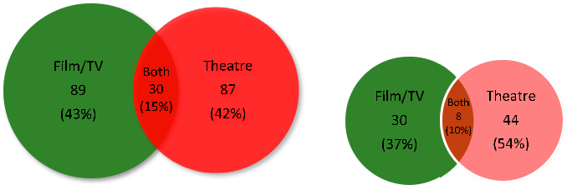

Figure 1. Total group (n = 206), interview group (n = 82) by sector where award won.

CULTURAL TRENDS  85

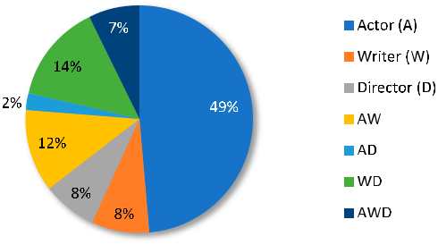

Figure 2. Total group (n = 206) by occupation.

Findings: education and state patronage

Education and early involvement

Figure 3 shows the educational attainment, with 71 per cent of the survey having a third-level degree or higher, well above the national average of 42 per cent (CSO, 2017). In relation to the occupation (not shown in Figure 3), there are some diﬀerences, with direc-tors being the most highly educated, 23 per cent of them possessing a postgraduate degree. Actors, on the other hand, are least likely to have attended College, although at 66 per cent their education level is still above average. It may be that actors may be more likely to learn their craft through training courses or “on the job”, that is by being cast in small roles, perhaps as children, and building up their careers through accumulat-ing experience.

Figure 4 provides data on first exposure to participation in drama, theatre and film. Clearly, school plays are an important introduction to performance, for all categories in fact. University societies also, it seems, were important for introducing creatives to their eventual careers, especially among directors. These societies provide ideal opportunities to form contacts/networks for later life as shall be seen. Many other “early exposure” factors were cited as can be seen in Figure 4. While the numbers are small, some talked of a “sympathetic” home environment (perhaps through parental interest or profession), and, interestingly, access to equipment (in the case of some who ended up making films for a career) proving motivational. This perhaps underlines the importance of early hands-on experience for developing this career interest. This may also have implications

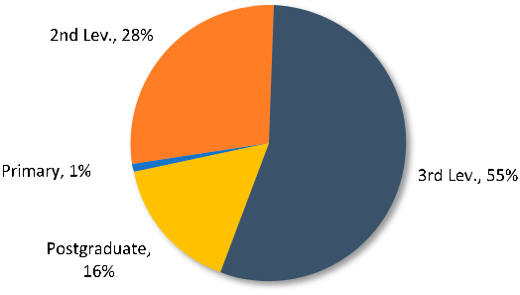

Figure 3. Formal education: highest level achieved (n = 82).

86  J. O’HAGAN ET AL.

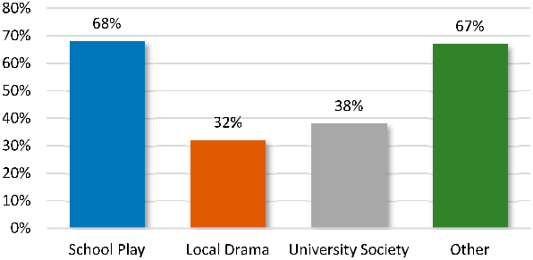

Figure 4. First exposure to theatre/filmmaking (n = 82).

for second-level education, where perhaps more practice-based media exposure might be of value. Equally, of course, it could be an anachronism, given that access to cameras has become much more widespread, than it would have been during the formative years of the film/TV directors interviewed.

State patronage

More than two-thirds of the sample group received direct grants or subsidy.15 As can be seen in Figure 5, almost 80 per cent of them indicated that this funding was extremely or very important for their careers. This is a strikingly high figure considering media comment over the years suggesting that funding levels were so low as to be meaningless to career development (see Barton & Murphy, 2020). It may be of course on the other hand that since the interviewees knew that this project was funded by a public agency, Creative Ireland, that they would overstate the importance of state funding. Nonetheless what is not in doubt is that 70 per cent of these prominent creative workers had received state funding in terms of grants and/or bursaries.

When these figures are broken down by occupation, it becomes clear that writers (88 per cent) and directors (90 per cent) particularly were most in receipt of state funding. Actors were less reliant, as they were probably less likely to be project initiators and reci-pients of development funding in both theatre and film/TV-drama (although they do of course benefit indirectly from employment on publicly funded projects). When asked to specify the main sources of public funding, a multitude of providers were listed, but the

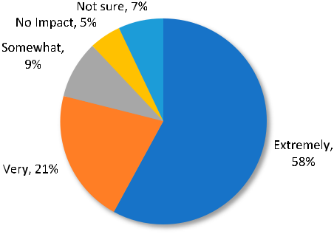

Figure 5. Public funding: helpfulness for career development (n = 82).

CULTURAL TRENDS  87

Arts Council of Ireland and Screen Ireland were the major sources of funds by far. Interest-ingly, the Artists’ Tax incentive in Ireland, which potentially applies to all writers of plays and screenplays was not mentioned by anyone, as almost certainly it does not apply to any of them perhaps. Their awareness of the tax incentives available at the sectoral levels though was also ascertained.

A very large proportion of the total are aware (as opposed to being in receipt of) not only of grants etc., but also tax breaks. Almost all consider public funding to be extremely important, again diﬃcult to interpret correctly. They might as mentioned have listed public funding as unimportant because of its low level, or in complete contrast overstated its importance in the drive to increase the levels of the funding involved. The interviewees were asked though at what stage of their careers they received state funding: 54 per cent stated early in their careers with only 9–11 per cent indicating late in career. This would suggest that public funding was indeed important in their development and that there may have been no incentive to overstate its importance. Thus, overall the evidence seems to be convincingly indicating that state patronage was a very important part of the career development of those interviewed.

This issue was looked at in another way. When asked to name (up to three) career breakthrough incidents (in their chosen field), interviewees listed a variety of roles, pro-jects, career events, etc, that were subsequently classified as in Figure 6).

Publicly funded theatre was the largest category, followed by publicly funded film and then publicly funded television. In total, publicly funded projects accounted for 76 per cent of all mentions, underlining the clear role of film, TV and theatre subsidy in launching pro-minent careers. This finding reinforces the above findings highlighting the centrality of public funding to career construction. As one interviewee noted, “Subsidised theatre is where people cut their teeth. It’s where we get our writers and directors and actors growing and being dangerous. Subsidised theatre is like the labour ward for film and TV.”

Findings: geographic location, supplementary work and networks

Residential location

Almost a quarter of interviewees reside outside Ireland, with the vast majority though living in Ireland. While there were no remarkable diﬀerences when these figures were broken down further, it seems that there was a greater propensity for women to be

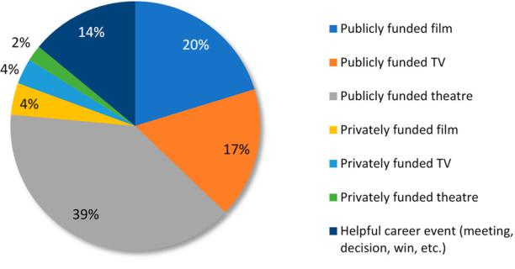

Figure 6. Career breakthroughs classified by type (n = 82).

88  J. O’HAGAN ET AL.

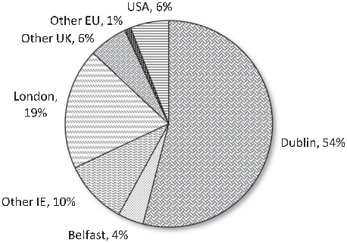

Figure 7. Residential location (n = 82).

resident abroad, although too much should not be suggested from this given the small numbers involved.

Looking at the place of residence (Figure 7), a clear picture emerges. The dominance of Dublin within Ireland and London for those UK-based is striking, with 73 per cent of all those interviewed, resident in one and/or other of these locations. As Dublin is a small city it is likely that many of these live geographically close to each other. Regarding occu-pation, residential location in London appears particularly important for actors; given the concentration of the theatre sector, and the late hours of work there would also suggest that they live in close geographic proximity. Figure 8 bears this out quite convincingly. Almost three-quarters live in close geographic proximity to others in the sector, and almost half consider near proximity to be very important, with a further quarter deeming it somewhat important.

It is perhaps surprising that so few individuals are based in the USA, given the impor-tance of Hollywood and Broadway and the long tradition of Irish creative workers moving there.

Supplementary work

While the information on incomes was not sought in the survey, as it was thought its inclusion might deter participation, some questions were asked about the extent and nature of supplementary work undertaken. The most common area by far for such work

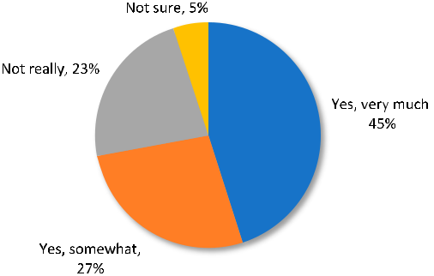

Figure 8. How much geographical proximity matters (n = 82).

CULTURAL TRENDS  89

was in advertising, with 65 per cent undertaking work there. The next most common types of supplementary work, at around one-fifth for each category, were music videos, work-shops, “related occupations” and teaching/lecturing.

Figure 9 breaks down the reliance on advertising by occupation, sector and gender. It is noteworthy that actors have the highest dependence, with directors having the least. Women also have a higher dependence, but the gap with men is not large.

The interviewees were asked then about the perceived creativity involved in such work, with a clear message emerging. In relation to the main supplementary work, namely advertising, the vast majority thought it had no or only a somewhat creative dimension (Figure 10). This would suggest that this type of work then is not particularly satisfying and therefore undertaken primarily to supplement low average and unpredictable incomes arising in the creative sectors discussed earlier. To quote again one of the interviewees.

At one point I was oﬀered [a role at The Abbey Theatre] and I turned down the job and a tour of America because I was the voiceover for a supermarket chain, and I was afraid I might lose the gig. I’m still shocked that I did that … . But it was so lucrative, I just couldn’t aﬀord not to do it.

It seems that involvement in music videos and other work is much more creative, especially in relation to the former. However, just around a fifth as mentioned already are involved in such work.

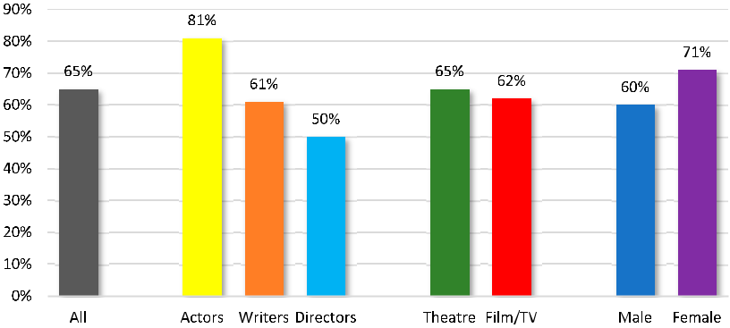

Figure 9. Reliance on advertising work to supplement income (n = 82).

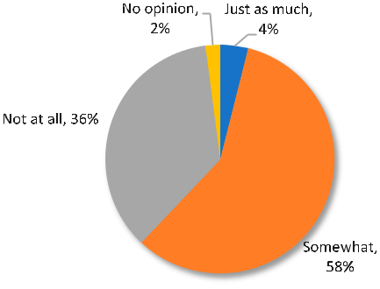

Figure 10. Creative content of advertising work (n = 82).

90  J. O’HAGAN ET AL.

Networks/personal connections

It was mentioned in the earlier sections that networks and personal connections have been shown to be important to career success for a variety of creative workers in a histori-cal context. As such, it is interesting to explore the existence and nature of such connec-tions, if any, for the group under study here. Figure 11 outlines the extent of such connections and their origins. As one might expect, early and recent career were the most important origins of current networks/personal connections.16 However, friendships at College were also listed for 40 per cent of the sample, with in some cases these lasting, judging from some responses, throughout life.

What was much more interesting to ascertain from the survey was the extent to which these connections were perceived as helpful/important and in what ways. Figure 12 por-trays a surprisingly strong perceived role for networks in career success. Almost three-quarters consider them greatly or very important to career success, with only seven per cent indicating that they were not at all important. If they are so important the question arises then in what ways. Three ways in which they help are very evident, as can be seen in Figure 13; jobs/work, ideas and moral support. This is much clearer evidence than pre-viously suggested by historical studies (see Mitchell, 2019; O’Hagan, 2019), and it is striking in its strength. What was also clear from the survey was how such work connections some-times developed into strong personal/family connections such as marriage, “best” friend-ships, godparent roles, and so on. Again, this is evident from anecdotal historical information in relation to prominent philosophers and writers (see O’Hagan & Walsh, 2016; and O’Hagan, 2019). As one interviewee stated, network relationships “make you

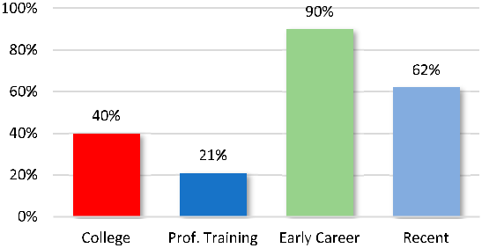

Figure 11. Networks and their origins (n = 82).

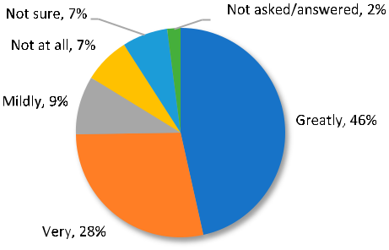

Figure 12. How important are networks? (n = 82).

CULTURAL TRENDS  91

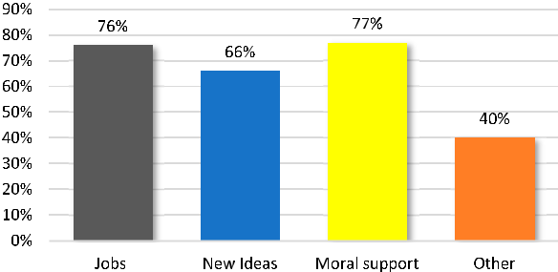

Figure 13. How networks help.

braver in the room because you know that people support you already, it makes you go further. There’s a huge amount of fear, fear of failure, fear of being found out. That’s why the support system is so important.”

Concluding reflections

The purpose of this paper, and the extensive interview programme underlying it, was to throw some light on the ecologies of creative careers in the film/TV-drama and theatre sectors in Ireland, thereby adding to the evidence base in general for such creative workers. It was shown how diﬀerent forms of early exposure to such work played a role in later career development, with school plays and local amateur productions emerging as particularly important. So also, did home background matter greatly for some, as well as university drama societies. It is also clear that this group have above average edu-cation, with over 70 per cent having a third-level degree or higher.

The role of state patronage in their career development is perceived as very strong, with not only a large proportion receiving such funding but most of them considering it very important to their early career development, a finding which is in line with the main ration-ale for such funding, namely providing the “space” for the exploration of innovative crea-tive output free from the constraints of the market place (see Frey & Pommerehne, 1989; and O’Hagan, 2016).

While the issue of low, average monetary incomes in the sector was not addressed in the survey, it was addressed in the empirical section in terms of what supplementary work the interviewees undertook and the creative nature, if any, of this work. Large percentages of them have been involved with supplementary work, most of it with very little creative content, suggesting that the main purpose is to earn an income to support the unpredict-able and often low level of income from their main occupation. Bear in mind that those under study here are the more prominent creatives, as all have won an Irish award or been nominated for an international award. This tallies with the findings of other studies (see for example Abbing, 2002; and Mangset et al., 2018).

The findings also confirm, in this instance, the belief that prominent creative workers tend to be geographically concentrated, for all the reasons stated in Section “Relevant fea-tures of the market for creative workers”. Not only are the creative workers under review in this study predominantly located in two places, Dublin particularly and also London, but the findings indicate that a large majority considers geographic proximity to be somewhat

92  J. O’HAGAN ET AL.

or very important. This is related to the later finding that a very large proportion of them consider networks/personal connections as very important to career success, connections which can best be facilitated through close geographic proximity. The benefits of such close personal connections it seems are threefold, as suggested by many other studies based simply on anecdotal evidence, namely: work/job contacts, the generation of ideas and moral support/understanding (see for example, Borowiecki, 2013; Collins, 1998; Mitchell, 2019; and O’Hagan, 2019)

It is important to acknowledge though that this survey, while the first of its kind in the Irish cultural industries, is necessarily limited by constraints of time, as noted in the earlier discussion on the sample of creative workers chosen for the study. We are confident though that the methodological approach adopted here can be applied to other cultural sectors, and also too the occupational categories in the sectors examined. Such a project would provide a more rounded picture of career construction across all sectors of the creative industries. Nonetheless, some policy implications can be suggested.

First, present levels of funding are evidently enabling careers in the creative industries. However, even the prominent individuals on which this study is based are dependent on supplementary work, with a worse situation probably applying to those outside this group, a concern therefore for cultural policy.

Second, there may be a need to reduce barriers to entry to the creative industries by incentivising entry to training programmes outside of third-level educational institutions, in all regions. This could counterbalance the current clustering of creative workers in these institutions, improving access and diversity. Very little funding is currently coming from private sources/philanthropy to support career development. Consideration needs to be given perhaps to restructuring the tax system to further incentivize sponsorship and investment. Creative workers require stronger state supports in order to be less dependent on non-creative ancillary income.

Third, it may be important to incentivize more women, through training programmes and mentorship, to apply for funding in order to address current gender imbalances (as illustrated in the more detailed work of Barton & Murphy, 2020). They argue that advocacy on behalf of excluded groups based on class, gender ethnicity, ability, etc. is needed to increase diversity in the creative industries.

It may also be that creativity needs to be embedded more in the school curriculum, and in teacher training, in order to inspire young children of all backgrounds to consider a career in the creative industries. Third-level education also often is and needs to be a space for experimentation and a conduit to the creative industries.

There is clear evidence from the survey that the theatre sector benefits the film and TV drama industry as a source of writing, acting and directing talent (see Barton & Murphy, 2020). To recognize this form of cross subsidy, additional funding should perhaps be allo-cated to training programmes that benefit both industries, with the creation of aﬀord-able creative living and working spaces in the principal Irish urban centres, given the evidence that creative workers cluster in large metropolitan areas as seen earlier. The benefits from this are two-way; cities have advantages for innovative work, but also the presence of innovative workers can make in turn cities more attractive (Andersson et al., 2014.)

CULTURAL TRENDS  93

Notes

1. The project and report upon which the data work in this paper is based was funded, following a competitive process, by The Creative Ireland Programme, a five-year initiative led by the Department of Culture, Heritage and the Gaeltacht, Dublin (see Barton & Murphy, 2020). We would also like to acknowledge the helpful and detailed comments of the three anon-ymous reviewers and the Editor, Dr Hye-Kyung Lee, for her gracious management of the review process.
2. It is hoped that later work will compare the sample of prominent creative workers looked at here to an equally large sample of those who have not received awards
3. Many of the most renowned creative workers in the past, they point out, were almost penni-less during their lifetime, but as always with many exceptions (Frey & Pommerehne, 1989). Johann Wolfgang von Goethe was, for example, an extraordinarily prominent author from the economic point of view. William Shakespeare was also a very wealthy man for his time, with three main sources of income; a fixed salary as an actor, profits from part-ownership of the Globe and Blackfriars Theatres, and further income for his work as a playwright. Georg Friedrich Handel lived like a wealthy gentleman and left a fortune in his will. Top opera singers, like top film stars today, were always paid exceedingly well and would have earned around €250,000 (in today’s money) each night at La Scala, for example. Star conduc-tors and directors of opera were paid even more.
4. This is true in many countries, but not all, especially in Germany where many actors and direc-tors still have permanent jobs.
5. See Abbing (2002) and Mangset et al (2018) for discussions of low incomes in the arts in diﬀerent national contexts.
6. To this end, Ireland’s Section 481 tax credit is competitive with similar schemes all over the world. It can refund up to 32 percent of local production costs and is therefore the most lucra-tive subsidy available in Europe (Barton & Murphy, 2020). On an individual level, eligible crea-tive writers, musicians, sculptors and painters can ‘shelter’ up to €50,000 per year from income tax under the so-called Artists Exemption scheme. In addition, donations to theatre companies are generally tax deductible, incentivising both personal and corporate patronage of the per-forming arts.
7. While none of the awards or nominations on which our sample is based includes a financial prize, some of the individuals in the sample have won considerable (usually literary) prizes such as the E.M. Forster Award or the Wyndham-Campbell Literature Prize.
8. Digital film production, for example, has seen the elimination or transformation of camera assistant roles such as clapper/loader, while creating new ones such as Digital Intermediate Supervisor. See also Caves (2002) for a more general discussion of the key features of the crea-tive industries market. Bourdieu (1993) provides an even wider perspective covering the general theme of cultural production.
9. West (1988) notes how the literary agent arose in response to the power imbalance between authors and publishers, as the latter became increasingly professionalised in the early 20th century. In the film industry, talent agents arose in diﬀerent circumstances. A series of events, most notably the decline of film audiences in response to competition from television and the forced divestment of the studios’ cinema exhibition divisions under antitrust legis-lation, saw the major Hollywood studios enter a long period of decline that ended the tra-ditional practice of long-term direct employment of actors, writers, directors, film technicians and studio craft workers. See Lingo and Tepper (2013) for a good discussion of the complexities with which creative workers must cope in their employment.
10. Lincoln (2007) examined award winners in a diﬀerent context, mainly in terms of the existence and causes of gendered age disparities.
11. Dublin and London could be described as a common labour market, but their proximity doesn’t necessarily mean that Irish creative workers must live in London.
12. How these awards are allocated is an issue looked at by Lincoln (2007). It is likely that there are biases in terms of race, gender and class in the allocation of these awards. The group is also

94  J. O’HAGAN ET AL.

not representative of all workers, just those who have received awards. We pondered how this might be overcome, but the problem came back to the same issue: what is the source for iden-tifying the ‘population’ and hence for coming up with a random sample of prominent creative workers in Ireland? There is to our knowledge no such reliable source.

1. A recent survey of European audio-visual authors, for example, had a response rate of 25 percent overall, with a slightly lower rate among Irish respondents (Willekens et al., 2019).
2. We considered the possibility of self-administered questionnaires, as they are much less labour intensive, but given the nature of the information sought considered face-to-face inter-views essential.
3. That is where the individual was a named recipient of the funding.
4. It may be that people are more open to new friendships at an early age as an explanation for this.

Funding

This work was supported by Creative Ireland.

Notes on contributors

John O’Hagan is Professor Emeritus, Economics, Trinity College Dublin. He has published widely on cultural economics and cultural policy.

Denis Murphy lectures in Film Studies at Trinity College Dublin. His forthcoming monograph on the labour history of Irish film and TV drama production will be published by Liverpool University Press.

Ruth Barton is Head of the School of Creative Arts and Associate Professor in Film Studies at Trinity College Dublin. She has written widely on Irish cinema. Her latest monograph, Irish Cinema in the Twenty-First Century, was published in 2019 by Manchester University Press.

References

Abbing, H. (2002). Why are Artists Poor: The Exceptional Economy of the Arts. Amsterdam University Press.

Andersson, A. Å. D., Daghbashyan, Z., & Hårsman, B. (2014). Location and spatial clustering of artists. Regional Science and Urban Economics, 47, 128–137. [https://doi.org/10.1016/j.regsciurbeco.2013.](https://doi.org/10.1016/j.regsciurbeco.2013.09.008) [09.008](https://doi.org/10.1016/j.regsciurbeco.2013.09.008)

Ashton, D. (2015). Creative work careers: Pathways and portfolios for the creative economy. Journal of Education and Work, 28(4), 388–406. <https://doi.org/10.1080/13639080.2014.997685>

Banks, M., & Hesmondhalgh, D. (2009). Looking for work in creative industries policy. International Journal of Cultural Policy, 15(4), 415–430. <https://doi.org/10.1080/10286630902923323>

Barton, R., & Murphy, D. (2020). Ecologies of Cultural Production: Career Construction in Irish Film, TV Drama and Theatre. Trinity College Dublin. [https://www.creativeireland.gov.ie/app/uploads/](https://www.creativeireland.gov.ie/app/uploads/2020/03/ECP.pdf) [2020/03/ECP.pdf](https://www.creativeireland.gov.ie/app/uploads/2020/03/ECP.pdf)

Bielby, W., & Bielby, D. (1999). Organizational mediation of project-based labor markets: Talent agencies and the careers of screenwriters. American Sociological Review, 64(1), 64–85. [https://](https://doi.org/10.2307/2657278) [doi.org/10.2307/2657278](https://doi.org/10.2307/2657278)

Borowiecki, K. (2013). Geographic clustering and productivity: An instrumental variable approach for classical composers. Journal of Urban Economics, 73(1), 94–110. [https://doi.org/10.1016/j.jue.2012.](https://doi.org/10.1016/j.jue.2012.07.004) [07.004](https://doi.org/10.1016/j.jue.2012.07.004)

Bourdieu, P. (1993). The Field of Cultural Production. Polity Press.

Bridgstock, R., Goldshmith, B., Rodgers, J., & Hearn, G. (2015). Creative graduate pathways within and beyond the creative industries. Journal of Education and Work, 28(4), 333–345. [https://doi.org/10.](https://doi.org/10.1080/13639080.2014.997682) [1080/13639080.2014.997682](https://doi.org/10.1080/13639080.2014.997682)

CULTURAL TRENDS  95

Bronfenbrenner, U. (1979). The Ecology of Human Development: Experiments by Nature and Design.

Harvard University Press.

Caves, R. (2002). Creative Industries: Contracts Between Art and Commerce. Harvard University Press.

Collins, R. (1998). The Sociology of Philosophies: A Global Theory of Intellectual Change. Harvard University Press.

Comunian, R., Faggian, A., & Jewell, S. (2011). ‘Winning and losing in the creative industries: An analy-sis of creative graduates’ career opportunities across creative disciplines’. Cultural Trends, 20(3-4), 291–308. <https://doi.org/10.1080/09548963.2011.589710>

CSO (2017). Census of population 2016 – Profile 10 Education, Skills and the Irish Language. Available at:

<https://www.cso.ie/en/releasesandpublications/ep/p-cp10esil/p10esil/>

Frey, B., & Pommerehne, W. (1989). Muses and Markets: Explorations in the Economics of the Arts.

Blackwell.

Greﬀe, X. (2002). Arts and Artists from an Economic Perspective. UNESCO. (English edition).

Hellmanzik, C. (2010). Location matters: Estimating cluster premiums for prominent modern artists.

European Economic Review, 54(2), 199–222. <https://doi.org/10.1016/j.euroecorev.2009.06.001> Jensen, M., & Kim, H. (2019). Reaching for the stars: The importance of reputational rank in creative career development. Poetics. online 24 December. <https://doi.org/10.1016/j.poetic.2019.101396> Lincoln, A. (2007). Cultural honours and career promotions: Re-conceptualizing prizes in the field of cultural production. Cultural Trends, 16(1), 3–15. <https://doi.org/10.1080/09548960601106904> Lingo, E., & Tepper, S. (2013). Looking back, looking forward: Arts-based careers and creative work.

Work and Occupations, 40(4), 337–363. <https://doi.org/10.1177/0730888413505229>

Mangset, P., Heian, M., Kleppe, B., & Løyland, K. (2018). ‘Why are artists getting poorer? About the reproduction of low income among artists. International Journal of Cultural Policy, 24(4), 539–

1. <https://doi.org/10.1080/10286632.2016.1218860>

Menger, P. M. (2006). Artistic labor markets: contingent work, excess supply and occupational risk management. In V. Ginsburgh & D. Throsby (Eds.), Handbook of the Economics of Art and Culture (pp. 765–811). North Holland.

Menger, P. M. (2015). The market for creative labour: talent and inequalities. In C. Jones, M. Lorenzen,

* J. Sapsed (Eds.), The Oxford Handbook of Creative Industries. Oxford: Oxford University Press. Mitchell, S. (2019). London calling; agglomeration economies in literary output. Journal of Urban

Economics, 112, 16–32. <https://doi.org/10.1016/j.jue.2019.05.002>

Noonan, C. (2015). Professional mobilities in the creative industries: The role of “place” for young people aspiring for a creative career. Cultural Trends, 24(4), 299–309. [https://doi.org/10.1080/](https://doi.org/10.1080/09548963.2015.1088121) [09548963.2015.1088121](https://doi.org/10.1080/09548963.2015.1088121)

O’Hagan, J. (2016). Objectives of arts funding agencies do not map well onto societal objectives. Cultural Trends, 25(4), 1–14. <https://doi.org/10.1080/09548963.2016.1241343>

O’Hagan, J. (2019). American Literary Output from early 19th to Late 20th Century: Age, Gender and Spatial Dimensions, Working Paper TRiSS, Trinity College Dublin. [https://www.tcd.ie/triss/assets/](https://www.tcd.ie/triss/assets/PDFs/wps/Triss-wps-04-2019.pdf) [PDFs/wps/Triss-wps-04-2019.pdf](https://www.tcd.ie/triss/assets/PDFs/wps/Triss-wps-04-2019.pdf)

O’Hagan, J., & Walsh, A. (2016). Historical migration and geographic clustering of prominent Western philosophers. Homo Oeconomicus: Journal of Behavioral and Institutional Economics, 34(1), 11–32. <https://doi.org/10.1007/s41412-016-0033-0>

Storper, M., & Venables, A. (2004). Buzz; face-to-face contact and the urban economy. Journal of Economic Geography, 4(1), 351–370. <https://doi.org/10.1093/jnlecg/lbh027>

Throsby, D., & Zednik, A. (2011). Multiple job-holding and artistic careers some empirical evidence. Cultural Trends, 20(1), 9–24. <https://doi.org/10.1080/09548963.2011.540809>

West, J. (1988). American Authors and the Literary Marketplace Since 1900. University of Pennsylvania Press.

Willekens, M., J. Siongers, L. Pissens and J. Lievens. (2019). Behind the screens: European survey on the remuneration of audiovisual authors. Available at: [http://www.filmdirectors.eu/wp-content/](http://www.filmdirectors.eu/wp-content/uploads/2019/03/EU-Audiovisual-Authors-remuneration-study-2019_FINAL.pdf) [uploads/2019/03/EU-Audiovisual-Authors-remuneration-study-2019_FINAL.pdf](http://www.filmdirectors.eu/wp-content/uploads/2019/03/EU-Audiovisual-Authors-remuneration-study-2019_FINAL.pdf)